**Ideation Phase**

**Brainstorm & Idea Prioritization Template**

|  |  |
| --- | --- |
| Date | 19 September 2022 |
| Team ID | PNT27022TMID2244 |
| Project Name | Project – Real Time Communication System Powered by AI For Specially Abled |
| Maximum Marks | 4 Marks |

STEP-1: SUMMARY AND PROBLEM STATEMENTS

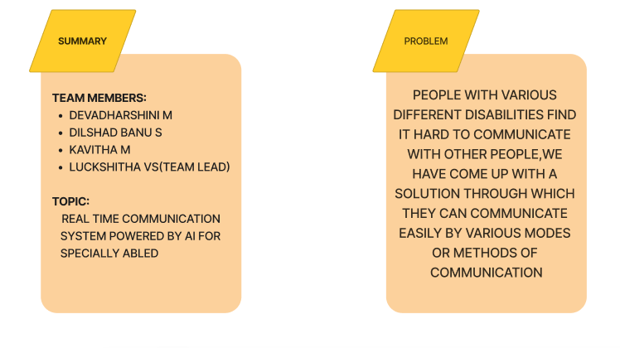

STEP-2: OBJECTIVE OF BRAINSTORM AND GROUP IDEAS

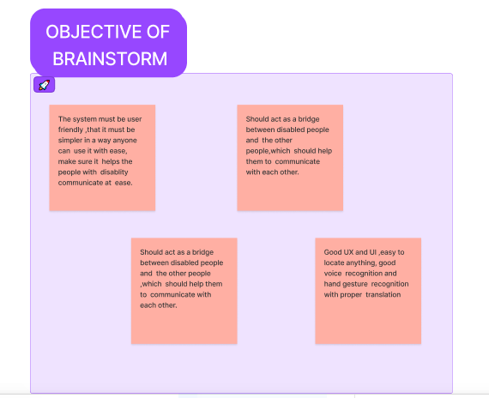

STEP-3: BRAIN STORM

